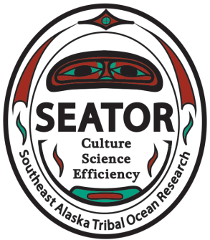
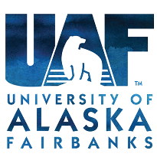
PUBLIC SERVICE ANNOUNCEMENT
Shellfish and Harmful Algal Bloom Advisory:
The University of Alaska Fairbanks School of Fisheries and Ocean Sciences in Juneau along with the Southeast Alaska Tribal Toxins (SEATT) partnership collected shellfish and phytoplankton samples at Auke Bay, Point Louisa (Auke Rec), Amalga Harbor and Eagle Beach to test for the presence of biotoxins, specifically paralytic shellfish poisoning (PSP). Shellfish samples were analyzed by The Sitka Tribe of Alaska Environmental Research Lab (STAERL). Recent samples collected on 6/1/16 confirm that shellfish at Auke Bay, Point Louisa (Auke Rec), Amalga and Eagle Beach all have elevated levels of toxins above the FDA regulatory limit of 80ug/100g and should not be harvested at this time. Elevated levels of Alexandrium, the phytoplankton species that produces saxtoxins causing PSP, were also observed at all 4 locations. Shellfish sampling updates will be available on the Southeast Alaska Tribal Ocean Research website (www.seator.org)
Any additional questions please contact:
Elizabeth Tobin
School of Fisheries & Ocean Sciences
University of Alaska Fairbanks, Juneau Division
907-796-5455
edtobin@alaska.edu

